Experiment – 7
Write a program to implement Logistic Regression (LR) algorithm in python

Aim
To implement the Logistic Regression (LR) algorithm using Python for binary classification and evaluate its performance on a dataset using Google Colab.

Algorithm
- Import the required Python libraries.
- Load a binary classification dataset.
- Split the dataset into training and testing sets.
- Standardize the feature values using StandardScaler.
- Create a Logistic Regression model.
- Train the model using the training dataset.
- Predict the class labels for the test dataset.
- Calculate the model accuracy.
- Display the confusion matrix and classification report.
- Interpret the classification performance.

Program:
# Logistic Regression Implementation

# Step 1: Import libraries
import numpy as np
import pandas as pd

from sklearn.datasets import load_breast_cancer
from sklearn.model_selection import train_test_split
from sklearn.preprocessing import StandardScaler
from sklearn.linear_model import LogisticRegression
from sklearn.metrics import accuracy_score, confusion_matrix, classification_report

# Step 2: Load dataset
data = load_breast_cancer()

X = data.data
y = data.target

# Step 3: Split dataset
X_train, X_test, y_train, y_test = train_test_split(
X, y, test_size=0.2, random_state=42
)

# Step 4: Feature Scaling
scaler = StandardScaler()

X_train = scaler.fit_transform(X_train)
X_test = scaler.transform(X_test)

# Step 5: Create Logistic Regression Model
model = LogisticRegression(max_iter=1000)

# Step 6: Train the model
model.fit(X_train, y_train)

# Step 7: Predict
y_pred = model.predict(X_test)

# Step 8: Accuracy
accuracy = accuracy_score(y_test, y_pred)

print("Accuracy:", round(accuracy * 100, 2), "%")

# Step 9: Confusion Matrix
print("\nConfusion Matrix:")
print(confusion_matrix(y_test, y_pred))

# Step 10: Classification Report
print("\nClassification Report:")
print(classification_report(y_test, y_pred))
Output:
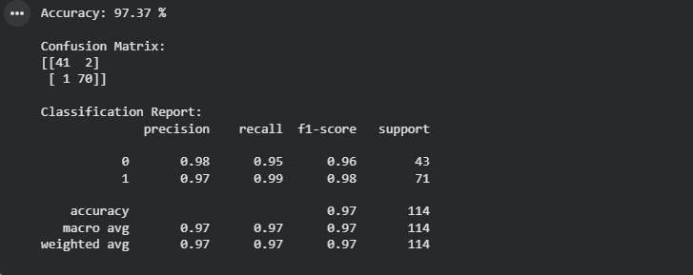
Result:
The Logistic Regression algorithm was successfully implemented using Python in Google Colab. The model was trained on the Breast Cancer dataset, performed binary classification on the test data, and achieved high classification accuracy. The confusion matrix and classification report confirmed that the model classified instances effectively with high precision, recall, and F1-score.

